Software Design Specification

GB DryFruits

Project Code:

SEP393846

Project Advisor:

Ms. Samreen Razzaq

Project Manager:

Dr. Muhammad Ilyas

Project Team:

Muhammad Sajid BSEF18M039 (Team leader)

Muhammad Saqlain BSEF18M038 (Team member)

Rafiuddin BSEF19M046 (Team member)

Submission Date:

Dec 22, 2022

_____________________
Project Manager’s Signature

Document Information

Category | Information
Customer | Department of CS & IT
Project | GB DryFruits
Document | Software Design Specification
Document Version | 1.0
Identifier | SEP181946
Status | Incomplete
Author(s) | Muhammad Sajid BSEF18M039 (Team Leader)  Muhammad Saqlain BSEF18M038 (Team Member)  Rafiuddin BSEF19M046 (Team Member)
Approver(s) | PM
Issue Date | Dec 4, 2022
Document Location
Distribution | - Advisor  - PM  - Project Office

Definition of Terms, Acronyms and Abbreviations

Term | Description
ASP | Active Server Pages
DS | Design Specification
SDS | Software Design Specification
GB | Gilgut Baltistan
ER | Entity Relationship
UML | Unified Modeling Language
GUIs | Graphic User Interfaces

Table of Contents
1. Introduction 3
1.1 Purpose of Document 3
1.2 Project Overview 3
1.3 Scope 3
2. Design Considerations 4
2.1 Assumptions and Dependencies 4
2.2 Risks and Volatile Areas 4
3. System Architecture 4
3.1 System Level Architecture 5
3.2 Deployment diagram 5
3.3 Sub-System / Component / Module Level Architecture 5
4. Design Strategies 6
4.1 Structure design strategy 6
4.2 Future enhancement 6
4.3 Three tier client server architecture 7
4.4 Reusability 7
5. Detailed System Design 7
5.1 Data Flow Diagram (0 Level / Context Level) 7
5.2 Data Flow Diagram (2 Level) 8
5.3 Class Diagram 8
5.4 Use Case Diagram 9
5.5 ER Diagram 11
6. Detailed GUIs 12
6.1 Login/Registration interface 12
6.2 Home page interface 12
6.3 About page interface 13
6.4 Product interface 13
7. References 14

1. Introduction

1.1 Purpose of Document
The System design document will gather and keep track of the important information needed to accurately define the architecture and system design in order to provide recommendations to the development team on the architecture of the system to be created. Creating design documentation is an iterative and progressive process that occurs throughout the system development life cycle. The degree of output that may be achieved is defined by the IT project requirements and the system development approach utilized to design the system. The whole project team, including the development team, and the project manager, should read it and everyone else engaged. Parts of this document, such as the user interface (UI), may be shared with the client or user, as well as any other stakeholders whose approval or comment is required.

1.2 Project Overview
GB Dry Fruits is a web-based application that will provide all the detail of dry fruits which one dry fruit is healthy and expensive. People from the areas like Gilgit Baltistan are facing difficulties to get the advantages from their own properties of dry fruits due to low selling and less buyers. Our main goal of the project is to provide doorstep delivery of delicious, freshly prepared dried fruits. Aware the people of Gilgit Baltistan of dry fruits preservation, standards, and value.

1.3 Scope
The functionalities that our website will provide are Selling and purchasing, adding to cart, updating cart, billing detail, shopping cart with express checkout, secured payment, WhatsApp chat integrations, preservation technique, map with direction, integrated social media, enquiry form, Home delivery, online payment, cash on delivery, discount offers. Our website will not be available all over Pakistan because of less agent and less resources. Our website only available for Gilgit Baltistan people.

2. Design Considerations
The main design considerations for the extra features are system performance, security, responsiveness, and scalability. The database is kept in MySQL to provide a great deal of flexibility in terms of scaling performance. For the device issues, we will use Bootstrap. It is critical to optimize your website for mobile. The design will take into account processor speed, memory, peripherals, and stakeholder support.

2.1 Assumptions and Dependencies
We had to make some assumptions about software design and the environment while designing this project. The Unified Modeling Language (UML) design diagrams in the Design Document are assumed to represent the system's view. The UML diagrams should be widely accepted and understood. The design definition is based on multiple diagrams that must be designed in order to configure the overall working structure of the system.

2.2 Risks and Volatile Areas
The system design carries very little risk. This is primarily because the existing system design and architecture will not be altered to meet the requirements of the proposed solution. We will only make updates about new products in our databases front-end through specific languages in the future. Financial risks are an issue. Funding for the proposed project has not been identified. The system's ongoing maintenance will also be a concern.

3. System Architecture
This section should provide a high-level overview of how the functionality and responsibilities of the system are partitioned and then assigned to subsystems or components. The main purpose is to gain a general understanding of how the system is decomposed, and how the individual parts work together to provide the desired functionality.

3.1 System Level Architecture

3.2 Deployment diagram
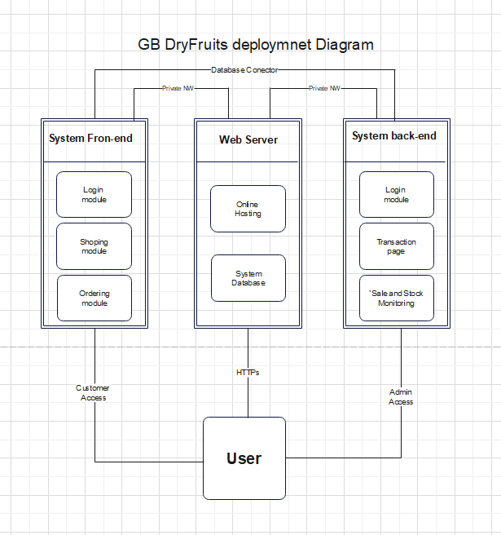

3.3 Sub-System / Component / Module Level Architecture

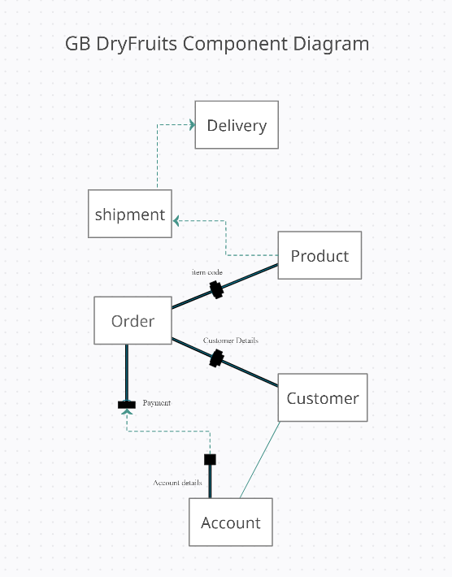

4. Design Strategies
This website will be developed by using the technique of divide and conquer. Basic idea is to partition the system into modules and sub-modules according to the functionality.
An integrated planning method that refers how design and business may complement one another is referred to as a design strategy. Simply, the concept is to bring a practical goal with creative ideas together that go beyond aesthetics. Here is the design approach that will be used to finish the design process.

4.1 Structure design strategy
It gives us the concept of different modules in a proper defined solution. This strategy will help us to be more focused on our issues. It works exactly like the word and conquer. This strategy makes it easier for us to give the accurate and precise solution module and build them up as a complete project.

4.2 Future enhancement
There is a possibility of enhancement in application's scope as cultivation trends are being changed. New crops details may be added with the passage of time.

4.3 Three tier client server architecture
The presentation tier is the user interface and communication layer of the application, where the end user interacts with the website. Web presentation tiers are usually developed using HTML, CSS and JavaScript.
The application tier is typically developed using Python, Java, Perl, PHP or Ruby, and communicates with the data tier using API calls. The data tier, sometimes called database tier, data access tier or back-end, is where the information processed by the application is stored and managed. MySQL will build this.

4.4 Reusability
The Dry Fruits Website will be designed following the principles of portability and interoperability. Its modules will be reused in other E-commerce Websites.

5. Detailed System Design

5.1 Data Flow Diagram (0 Level / Context Level)

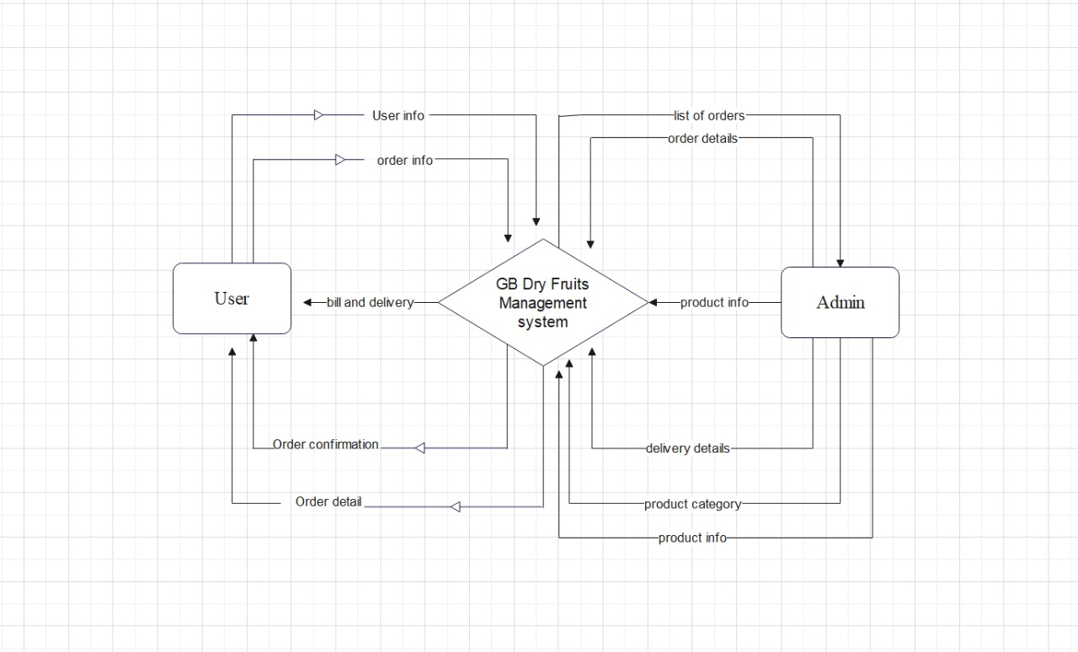

5.2 Data Flow Diagram (2 Level)

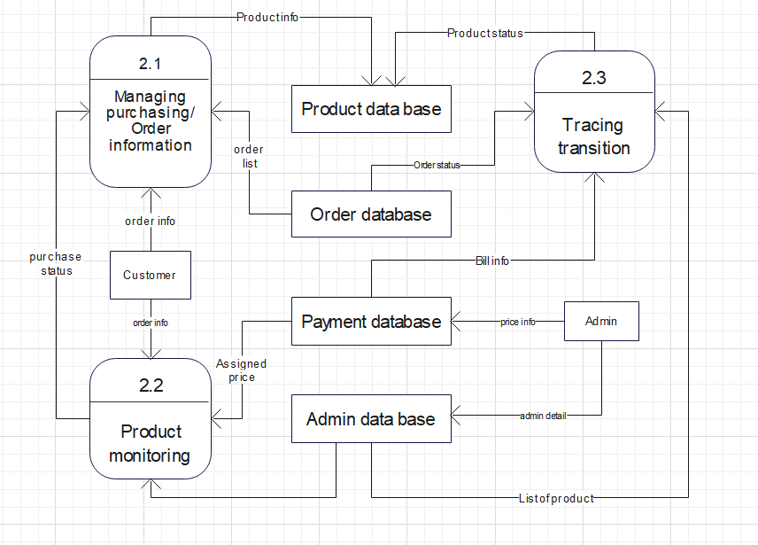

5.3 Class Diagram

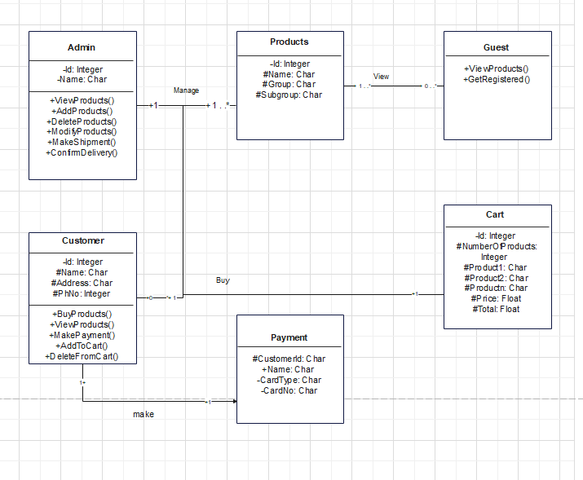

5.4 Use Case Diagram

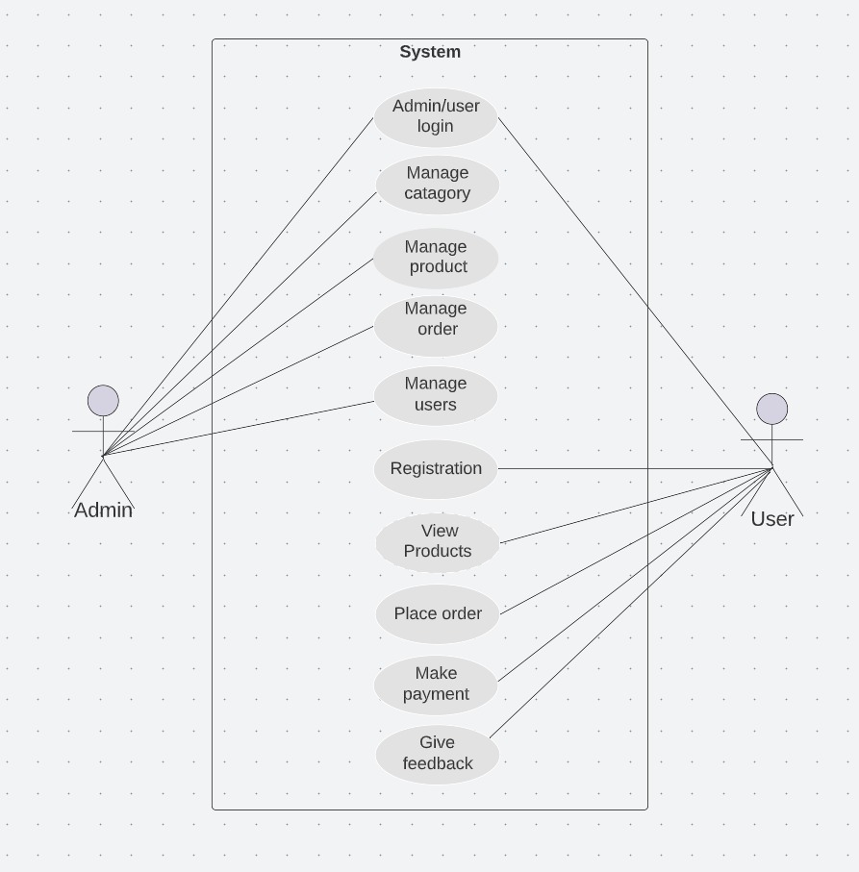

5.5 ER Diagram

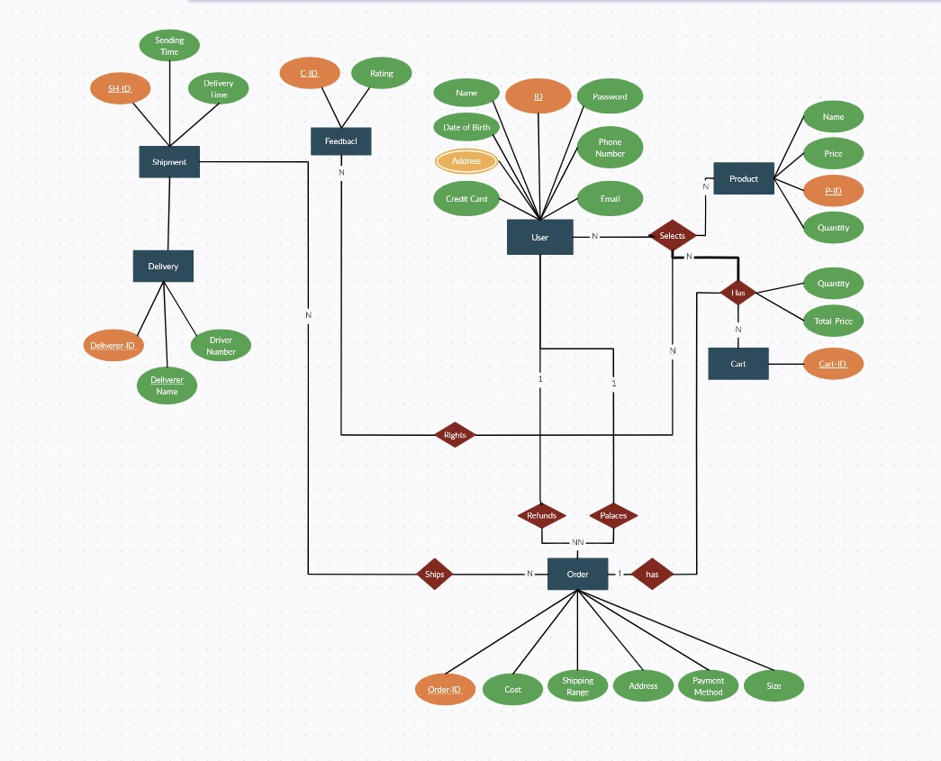

6. Detailed GUIs

6.1 Login/Registration interface

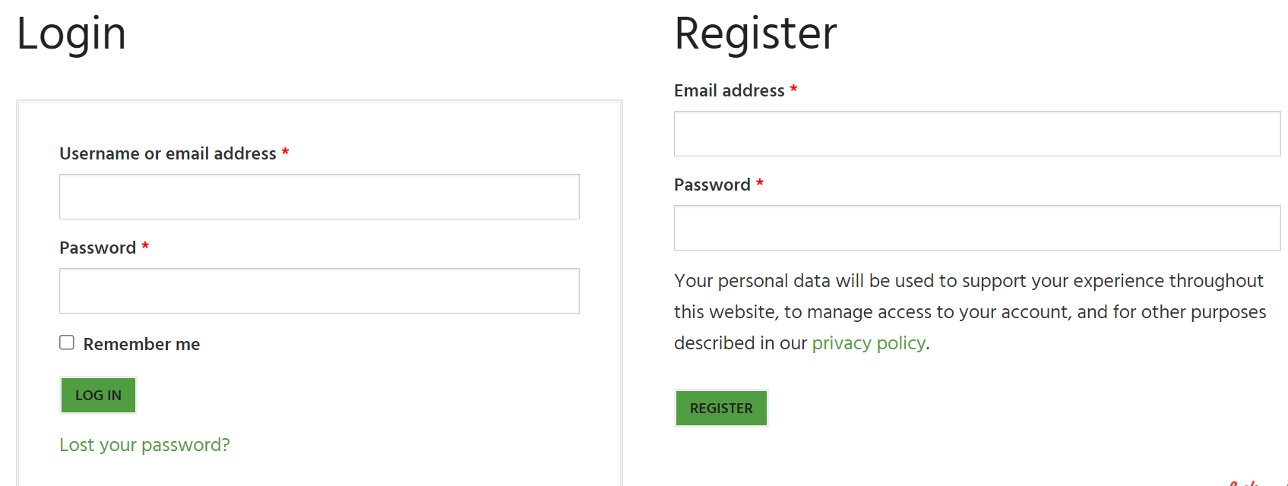

6.2 Home page interface

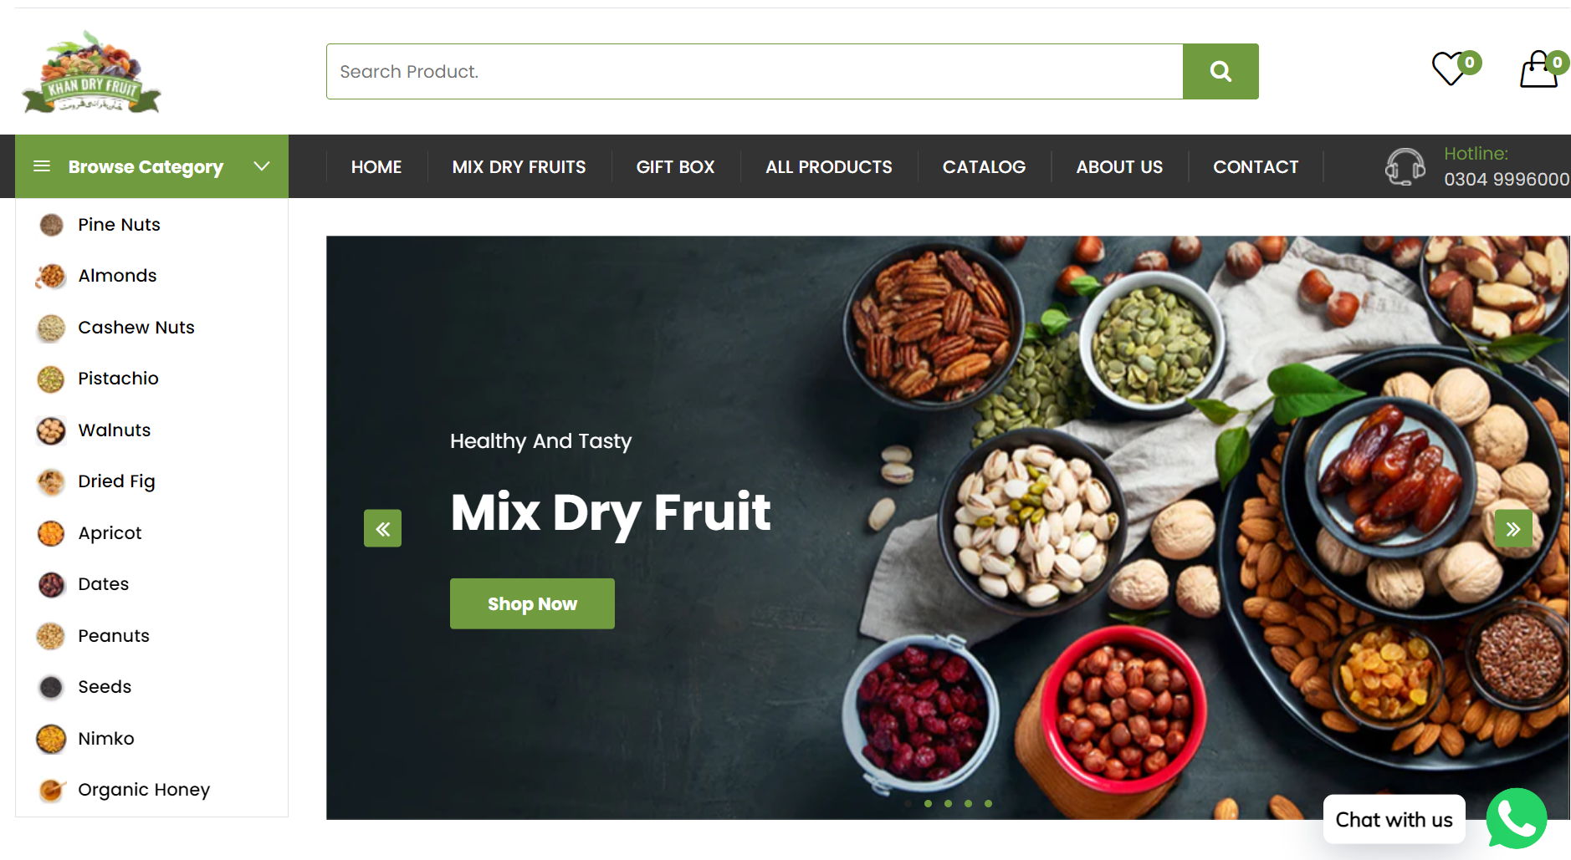

6.3 About page interface

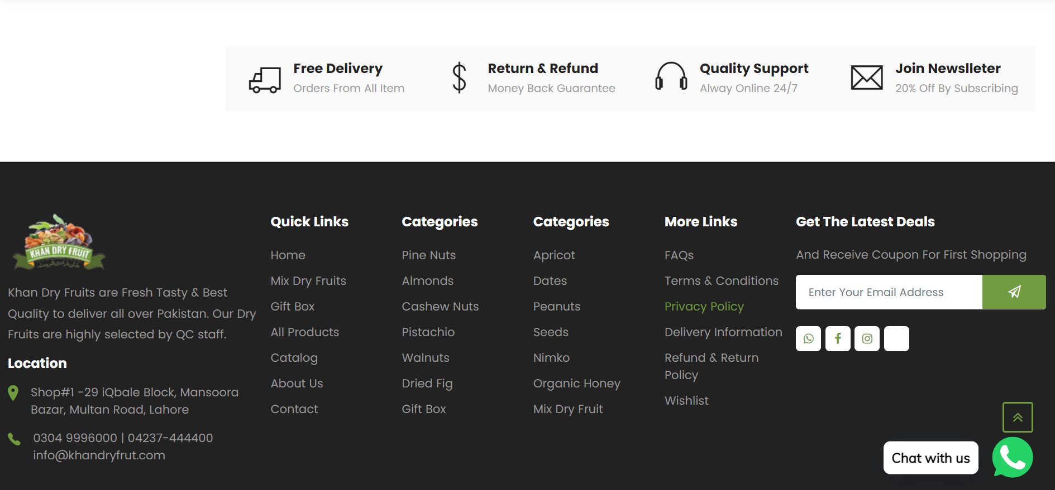

6.4 Product interface

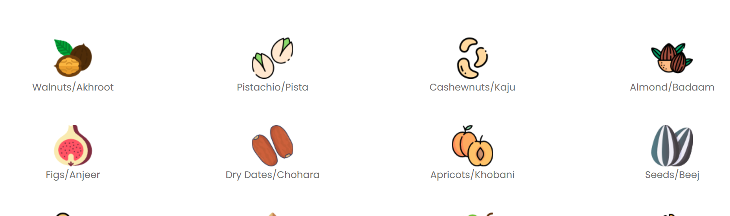

7. References
- [1] “Get Microsoft Bing,” Microsoft Store. https://www.microsoft.com/en-us/p/microsoft-bing/9nnhpwj0r912 (accessed Nov. 08, 2022).
- [2] “Netscape ISP Homepage.” https://isp.netscape.com/ (accessed Nov. 08, 2022).
- [3] “‘ibm,’ [Online]. Available: https://developer.ibm.com. - Google Search.” https://www.google.com/search?q=%22ibm%2C%22+%5BOnline%5D.+Available%3A+https%3A%2F%2Fdeveloper.ibm.com.&rlz=1C1GCEA_enPK1028PK1028&oq=%22ibm%2C%22+%5BOnline%5D.+Available%3A+https%3A%2F%2Fdeveloper.ibm.com.&aqs=chrome..69i57j33i160l4.1339j0j7&sourceid=chrome&ie=UTF-8 (accessed Nov. 08, 2022).
- [4] S. Chatterjee, “Security and privacy issues in E-Commerce: A proposed guidelines to mitigate the risk,” in 2015 IEEE International Advance Computing Conference (IACC), 2015, pp. 393–396.
- [5] C. Zott, R. Amit, and J. Donlevy, “Strategies for value creation in e-commerce:: best practice in Europe,” European Management Journal, vol. 18, no. 5, pp. 463–475, 2000.
- [6] R. R. Harmon, “Marketing Information Systems.,” Encyclopedia of information systems, vol. 3, pp. 137–151, 2002.
- [7] S. Bagchi, G. Kar, and J. Hellerstein, “Dependency analysis in distributed systems using fault injection: Application to problem determination in an e-commerce environment,” 2001.
- [8] E. L.-C. Law, V. Roto, M. Hassenzahl, A. P. Vermeeren, and J. Kort, “Understanding, scoping and defining user experience: a survey approach,” in Proceedings of the SIGCHI conference on human factors in computing systems, 2009, pp. 719–728.
- [9] S. Gauch, M. Speretta, A. Chandramouli, and A. Micarelli, “User profiles for personalized information access,” The adaptive web, pp. 54–89, 2007.

Ref. No. | Document Title | Date of Release/ Publication | Document Source
SEP383946 | Project Proposal | Oct 08, 2022 | D:\desktop\cp-1 project files
SEP383946 | Functional Specification | Oct 19, 2022 | D:\desktop\cp-1 project files

